Covid19 Secure Measures Risk Assessment Example / template

Office and similar Environment

Introduction
- This form is intended to assist XXXXX Council (the employer) in meeting their legal obligation to protect the health safety and welfare of our employees by assessing and managing risks in relation to coronavirus in the workplace.

- This form was developed in line with the government guidance https://www.gov.uk/guidance/working-safely-during-coronavirus-covid-19/offices-and-contact-centres and covers indoor environments such as offices, contact centres, operation rooms and similar workplaces.

- Risk assessments should be carried out for each separate department/service office space by the Manager and done in conjunction with the Trade Unions.

- Additional individual risk assessments are needed for any employee who has any factor which places them at higher risk or in a vulnerable category and for all factors consideration must be given to adjustments for any employees with any protected characteristics.

- Additional role-based risk assessments may be needed over and above the workplace assessments where the nature of the work is impacted by the risk of Covid-19 transmission.

- This risk assessment should also be reviewed when the working location, duties, or situation of the employees change.

- There are five key principles which guide decisions and ensuring covid19 secure measures:

1. Work from home, if you can
2. Carry out a COVID-19 risk assessment, in consultation with workers or trade unions
3. Maintain 2 metres social distancing, wherever possible
4. Where people cannot be 2 metres apart, manage transmission risk
5. Reinforce cleaning processes

Therefore, the advice is that where it is possible employees should work from home.

- Results of the risk assessment must be shared with the workforce and the government expects employers with over 50 employees to share their results on their website.

Covid19 Secure Measures Risk Assessment Example / template - Office

Process
- The Covid19 Secure guidance identifies key areas where risk needs to be assessed and managed.

- This template will provide a systematic process to assess risk using the following matrix.
SEVERITY
H&S | No Injury | Slight | Minor | Serious | Major

LIKELIHOOD | Unlikely |  | 1 | 2 | 3 | 4 | 5 |  |  | MINOR
 | Possible |  | 2 | 4 | 6 | 8 | 10
 | Likely |  | 3 | 6 | 9 | 12 | 15 |  |  | SIGNIFICANT
 | Very Possible |  | 4 | 8 | 12 | 16 | 20
 | Almost Certain |  | 5 | 10 | 15 | 20 | 25 |  |  | MAJOR

RISK RANKING
1 – 5 | MINOR RISK | MONITORING REQUIRED
6 – 15 | SIGNIFICANT RISK | LOOK TO IMPROVE / REDUCTION OF RISK REQUIRED
16 - 25 | MAJOR RISK | STOP PROCESS - TAKE IMMEDIATE ACTION

- The assessment recognises that the transmission of Coronavirus in the workplace, in the areas outlined in the Covid19 Secure Guidance is a hazard. The virus is spread in minute water droplets that are expelled from the body through sneezing, coughing, talking and breathing. The virus can be transferred to the hands and from there to surfaces. It can survive on surfaces for a period after transfer (depending on such things as the surface type, its moisture content and temperature). If it is passed from one person to another, while many survive infection, some may die from the disease. It should be regarded as a severe hazard.
- Likelihood considers how people are likely to be exposed. With no control measures in place the likelihood is potentially high.

- Therefore, without control measures the risk to health should be considered as a MAJOR RISK. The following assessment of the workplace risks outlined in the Covid19 Secure measures guidance should be undertaken or the elements of risk assesses under existing risk assessment processes.

- The hierarchy of control should be applied, and the highest level of control implemented. Elimination is not possible as the employer is unable to completely remove the threat of the virus in the workplace. Substitution is not possible as there is no less harmful alternative available in the workplace.

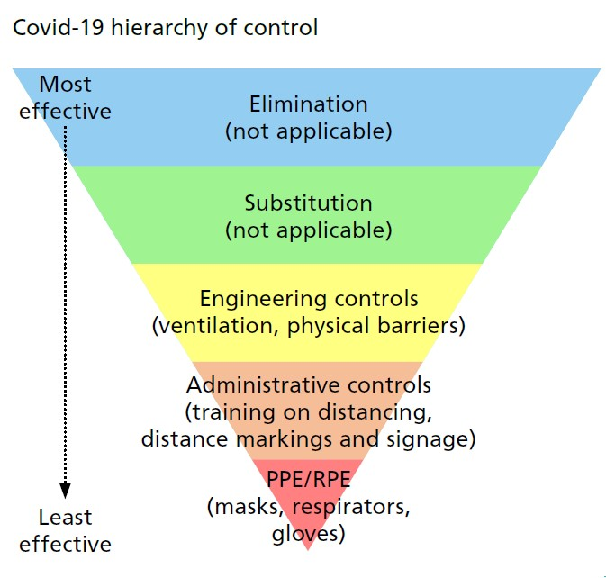

Service/Team/Department |  | Date
Exact Location
Completed by (name and Job Title) |  | Signature

Section 1 – Social Distancing
Activity | Control measures | Y/N | Comments/other control measures | Risk after control measures
 |  |  |  | Severity | Likelihood | Risk
Travelling to work | There is communication to employees to discourage use of public transport
 | Additional car parking has been identified
Bike storage is
available

 | Passenger numbers in any LA vehicles is limited and stipulated

Activity | Control measures | Y/N | Comments/other control measures |  | Risk after control measures
 |  |  |  |  | Severity | Likelihood | Risk
Arriving at and leaving work | Staggering of arrival times/leaving times/shifts has been implemented  Reduced numbers of employees required on site has been established  Additional, individual storage for clothing/bags is available
Entry points | Increase in number of entry points
 | Protocols for one-way flow at entry/exit points which are clearly marked is in place
Discontinuation of touch-based security
entrances including turn styles is established
 | Hand sanitiser is available at all entry points

Activity | Control measures | Y/N | Comments/other control measures |  | Risk after control measures
 |  |  |  |  | Severity | Likelihood | Risk
Moving around the workplace | One-way systems are in place
 | Direction of travel in corridors is marked
Lift access is restricted for disabled employees/those with specific conditions or need only
Reduced lift capacity and clear marking is installed
 | Hand sanitiser is provided in lifts
 | Employees are discouraged from non-essential trips around the building
 | There is restricted access to certain areas
 | Use of telephone/email contact between offices/departments is encouraged
 | Use of stairs is actively encouraged

Activity | Control measures | Y/N | Comments/other control measures | Risk after control measures
 |  |  |  | Severity | Likelihood | Risk
Meetings | Remote tools are used to reduce the need for face to face meetings
 | Number of participants attending face to face meetings is minimised
 | 2m distance between participants is maintained
 | The largest capacity room available is used
 | Floor markings to ensure social distancing are installed in meeting rooms
 | Employees are instructed to avoid sharing physical resources during meetings
 | Employees are instructed to avoid communal food during meetings
 | Hand sanitiser is provided in meeting rooms

Activity | Control measures | Y/N | Comments/other control measures |  | Risk after control measures
 |  |  |  |  | Severity | Likelihood | Risk
Common Areas | Staggered break times have been implemented
 | Use of outside break areas is in place where appropriate
 | Additional break areas have been created
 | Screens have been installed where appropriate, e.g. reception areas
 | Floor markings to maintain social distancing have been installed
 | Seating has been reconfigured to reduce capacity and reduce face to face interactions
 | Employees are encouraged to remain on-site
 | Employees are encouraged to bring their own food
Activity | Control measures | Y/N | Comments/other control measures |  | Risk after control measures
 |  |  |  |  | Severity | Likelihood | Risk
Packaged meals are provided to avoid opening canteens fully
Use of locker rooms, changing areas and other facilities is subject to established protocols

 | Hand sanitiser and cleaning products are provided where there are communal items such as kettles/microwaves
Accidents, security and other incidents | First aiders are provided with hand sanitiser and PPE where appropriate
 | Employees are aware that in an emergency situation, e.g. fire evacuation social distancing does not apply
 | Fire Marshals and security staff roles are assessed separately

Section 2 – Managing Contacts

Activity | Control measures | Y/N | Comments/other control measures | Risk after control measures
 |  |  |  | Severity | Likelihood | Risk
Visitors and contacts | Remote contacts are encouraged and enabled as far as possible
 | Clear protocols are developed, displayed and communicated for all visitors
 | The number of visitors to the premises is limited
 | Clear social distancing floor markings are in place for queues
 | Schedules have been revised to limit numbers on site e.g. contractors and routine maintenance
 | Maintenance is reviewed to consider that which can be undertaken outside of normal working hours

Activity | Control measures | Y/N | Comments/other control measures | Risk after control measures
 |  |  |  | Severity | Likelihood | Risk
 | Hand sanitiser is provided for visitors
 | Entry and exit points and flow of visitors has been reviewed and protocols established
 | non-contact payment methods and options are provided
Providing and Explaining guidance | Signs and visual aids are displayed at points of entry and at multiple points in visitor areas
 | Tenant organisations in the building are adhering to covid19 secure measures
 | Employees interacting with visitors e.g. reception, security, etc are provided with necessary training on safe working measures

Section 3 – Cleaning

Activity | Control measures | Y/N | Comments/other control measures | Risk after control measures
 |  |  |  | Severity | Likelihood | Risk
Before opening | Air conditioning and ventilation maintenance is up to date
 | Where possible regular opening of windows for increased ventilation is in place
Keeping the workplace clean | Building cleaning schedules have been reviewed and increase frequency where necessary
 | All equipment is cleaned between uses
 | Safe, disposable cleaning materials are provided for employees to use
 | Frequent cleaning of regularly touched surfaces, objects such as door handles has been introduced

Activity | Control measures |  | Y/N |  | Comments/other control measures |  | Risk after control measures
 |  |  |  |  |  |  | Severity |  | Likelihood | Risk
 | Waste is removed at the end of each day
 | Guidance is followed in the event of a known or suspected covid19 case in the workplace
 | Use of high touch items such as printers has been reviewed and protocols communicated
Hygiene, handwashing, sanitation facilities and toilets | Posters are displayed to build awareness of handwashing techniques
 | Posters are displayed to build awareness of hygiene protocols e.g. avoid face touching, binning tissues etc.
 | Hand sanitiser is provided in multiple locations
 | Toilet cleaning schedules have been reviewed

Activity | Control measures |  | Y/N |  | Comments/other control measures |  | Risk after control measures
 |  |  |  |  |  |  | Severity |  | Likelihood | Risk
 | Monitoring of toilet cleaning schedules is undertaken
 | The most used facilities are cleaned more frequently
 | Guidelines on using toilet facilities have been shared with staff to achieve social distancing e.g. use only facilities close to your office
Changing rooms and showers | Changing rooms and showers should only be used where necessary – protocols of use have been communicated to staff
 | Cleaning schedules have been reviewed
 | Cleaning is monitored

Activity | Control measures |  | Y/N |  | Comments/other control measures |  | Risk after control measures
 |  |  |  |  |  |  | Severity |  | Likelihood | Risk
Good handling, deliveries, onsite vehicles | Cleaning protocols have been established for incoming deliveries and goods
 | Hand sanitiser and hand washing protocols have been established for staff handling deliveries
 | Protocols have been communicated to staff and information is displayed
 | Employees are not permitted to arrange personal deliveries to work addresses
 | LA vehicles cleaning schedules have been reviewed
 | Shared vehicles are cleaned in between each use
 | Hand sanitiser is provided in vehicles
 | Delivery schedules have been reviewed to minimise contact
Activity | Control measures |  | Y/N |  | Comments/other control measures |  | Risk after control measures
 |  |  |  |  |  |  | Severity |  | Likelihood | Risk
 | Drop off points have been reviewed to include procedures, signage and markings
 | Non-contact deliveries are established where possible
PPE and face coverings | Roles requiring PPE have been identified
 | PPE procurement has been reviewed
 | Employees wishing to wear face coverings are permitted to do so – guidelines on safe use of face coverings is displayed and communicated

Section 4 – Workforce Management
Activity | Control measures | Y/N | Comments/other control measures | Risk after control measures
 |  |  |  | Severity | Likelihood | Risk
Shift patterns and working groups | Shift patterns have been reviewed to minimise contact
 | Shift patterns have been fixed as far as possible
 | Working groups/teams have been fixed as far as possible
 | Employees are clear on what days/times they should be attending work
 | Areas of common use between different teams and shifts have been identified
 | Cleaning protocols have been established
Activity | Control measures | Y/N | Comments/other control measures | Risk after control measures
 |  |  |  | Severity | Likelihood | Risk
Work related travel, cars, accommodation and visits | All except non-essential visits have been cancelled or postponed or remote options have been implemented
 | Overnight accommodation venues comply with covid19 secure measures
 | Social distancing measures are applied to visits where possible
 | PPE is supplied for visits where required by role
 | Records are kept of overnight stays
 | Shared vehicles are cleaned between shifts/handover

Activity | Control measures | Y/N | Comments/other control measures | Risk after control measures
 |  |  |  | Severity | Likelihood | Risk
 | Where transfer of equipment, etc. is required between sites - procedures to minimise person to person contact have been established and communicated to employees
Communication and training | Clear, consistent and regular communication methods are in place
 | Employees and Trade Unions are engaged and involved in developing safe working measures
 | Employees have received communication and training materials prior to returning to work
 | New procedures have been communicated to employees
 | Regular review and monitoring of measures has been scheduled
 | Changes to existing practices are discussed and agreed with Trade Unions
Activity | Control measures | Y/N | Comments/other control measures | Risk after control measures
 |  |  |  | Severity | Likelihood | Risk
 | Communication material includes images and is available in different formats/ languages where appropriate
 | Employees mental health is a key focus and support measures have been identified and implemented
 | A communication strategy has been established to ensure that all employees are updated regularly

